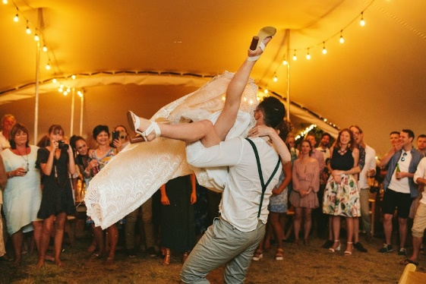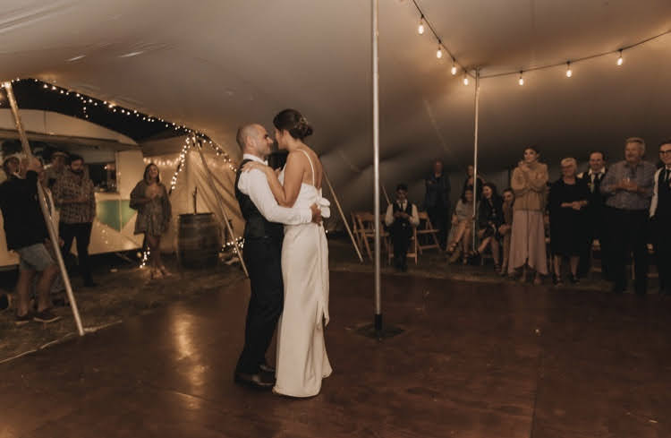

**Dance Floor Package**

Lets’ face it – planning a wedding can be stressful so we have created a simple and cost-effective package solution for your wedding, to help you get the basics sorted.

The Dance Floor Package is designed for most sizes of wedding / celebration events and is priced at $710.00 incl GST.

**Customise the package**

Need to customise the package for your particular event? No problem! - contact us and we’ll work together to create a package specially for you.

Prices include GST. Usual price $790.00 incl GST.

**Great savings!**

**The Package**

The dance floor package includes the following:

• Timber dance floor 4.8mtr x 4.8mtr – your choice of Black, Light Oak or Mahogany

• 800 watt Sound System – incl twin speakers on stands, mixing desk, wireless microphone, Bluetooth or direct connection to devices.

• LED with laser and strobe – an amazing effect light that combines the power of 4 popular effects in 1!

**Great Savings!**