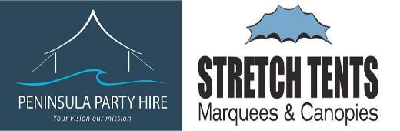

**Our step by step process**

We will be excited to receive your enquiry and we will do our best to reply within 24 hours. (During peak season please expect some delays). As we discuss your requirements we will continue to respond promptly. We encourage you to ask questions, we have the knowledge and experience to help you create your vision. We are happy to do site visits, and we welcome you to visit us.

We will provide you with a confirmed Quote and confirmation that all products quoted are available for your nominated dates at time of quoting.

When you have paid your 25% deposit, we will confirm your Booking and send you a copy showing the deposit amount paid and the balance. Adjustments to your booking are expected and welcomed – no further deposit money required. As your idea’s evolve, and RSVP’s confirmed we will continue to adjust your booking as required.

If a building consent is required, we will send out the paperwork 2 months prior to your booking. We prepare consents free of charge, and on-charge Council permit costs to you.

1 month prior to your booking we will send you some information, forms to fill out, and our Terms and Conditions for you to sign off.

The week before your event we will contact you to see if you have any last-minute changes, and to confirm our delivery schedule. We will always try to be flexible and to work in with you. We have a standard hire period of three to four days. We like to give you time to set up, then relax and enjoy your Big Day with your guests.

The day before your event our trucks will be loaded with all your gear, ready for an on-time delivery.

The day of delivery- our energetic crew will arrive and be ready for action. Ideally you will be there to meet us so you can confirm exact location and orientation of marquee. We are happy to help guide you. The marquee will then be erected, lighting installed, table, chairs and other hire items will be stacked inside the marquee ready for you to set up once we have departed. This is a highlight for us as we see the excitement growing!

If you have any issues or problems, we will do our best to sort them promptly! ....

Pack down – we will agree a day/time to pack down. We will arrive promptly and work quickly so you will not be inconvenienced.

f

Every job is special – we love to hear about your big day and check out your pictures. We will be in touch when the season is over, for feedback and photos.

Your Vision- Our Mission

**Our Promise to You – How we do Business**

Peninsula Party Hire is a family business, and we will endeavour to develop a personal relationship with our clients from beginning to end. We take pride in all our products and will always go the extra mile for you.